Wednesday, 09 March 2016

Jomin Kaitholil George

CSC3122 – Mobile Computer Systems Development

Hospitality - Business Case

Prepared By: Jomin Kaitholil George

Document Version: 1.0

**Executive Summary**

NHS provides high quality care for their patient, and would require a system in place where it will provide the patient with the services that are offered by NHS within a given postcode radius. In addition, it is always hard to keep up with appointments and bookings at hospital, within this mobile application it will make it easier for the end user to track their individual bookings and appointments. Providing the end user with an android application that allows them to find all the necessary details that they would require instead of having to call up the nearest hospital and having to wait for an answer.

**Business Need and Current Situation**

Since there is a lot of services that NHS provide for the patient it is very hard to find information (e.g. finding nearest eye clinic) and due to this problem it results in not being able to get the care that the patient is after at the right time. In addition, there is a high chance of not turning up the appointments that a patient is been booked in for. It can be difficult to remember all of this details and also a human error can happen at any time (e.g. patient writing down the appointment date wrong). Due to many other problems caused by not having a system in place to give the patient much more clearer understanding of the services that NHS provides, it results in patient left out from the care that they should be getting.

**Solution Options**

The potential solution to the problem would be to provide the end user with the full services that NHS provides with their patient. This involves in giving the ability for the patient to find a service that is close by to them (e.g. finding nearest eye clinic in a radius of 5 miles from a given postcode). In addition, within the android application, there should be a functionality that provides the end user with their individual appointments and have the ability to set remainders for their self (e.g. pick-up prescription from a surgery). My Local NHS is an android application that I have used to compare my ideas against with, these are some of the features that application provides:

* Find all services (10 miles radius from the specified postcode)
* Call 999/111 and providing information about both of these numbers
* Links to useful websites (e.g. NHS.uk)
* Take notes and saving it

These are some of the images from the application:

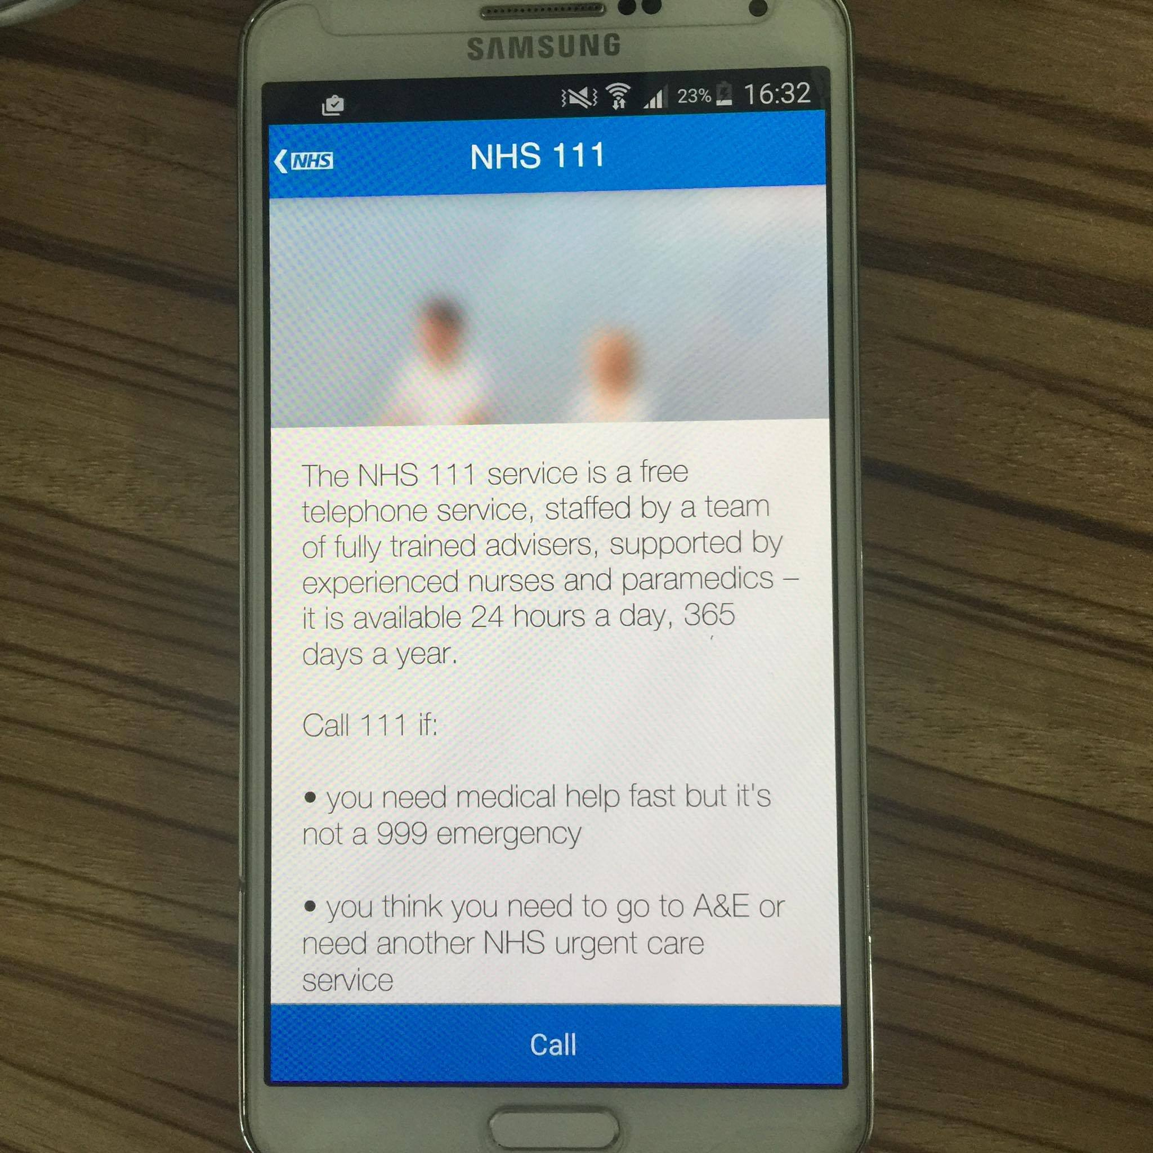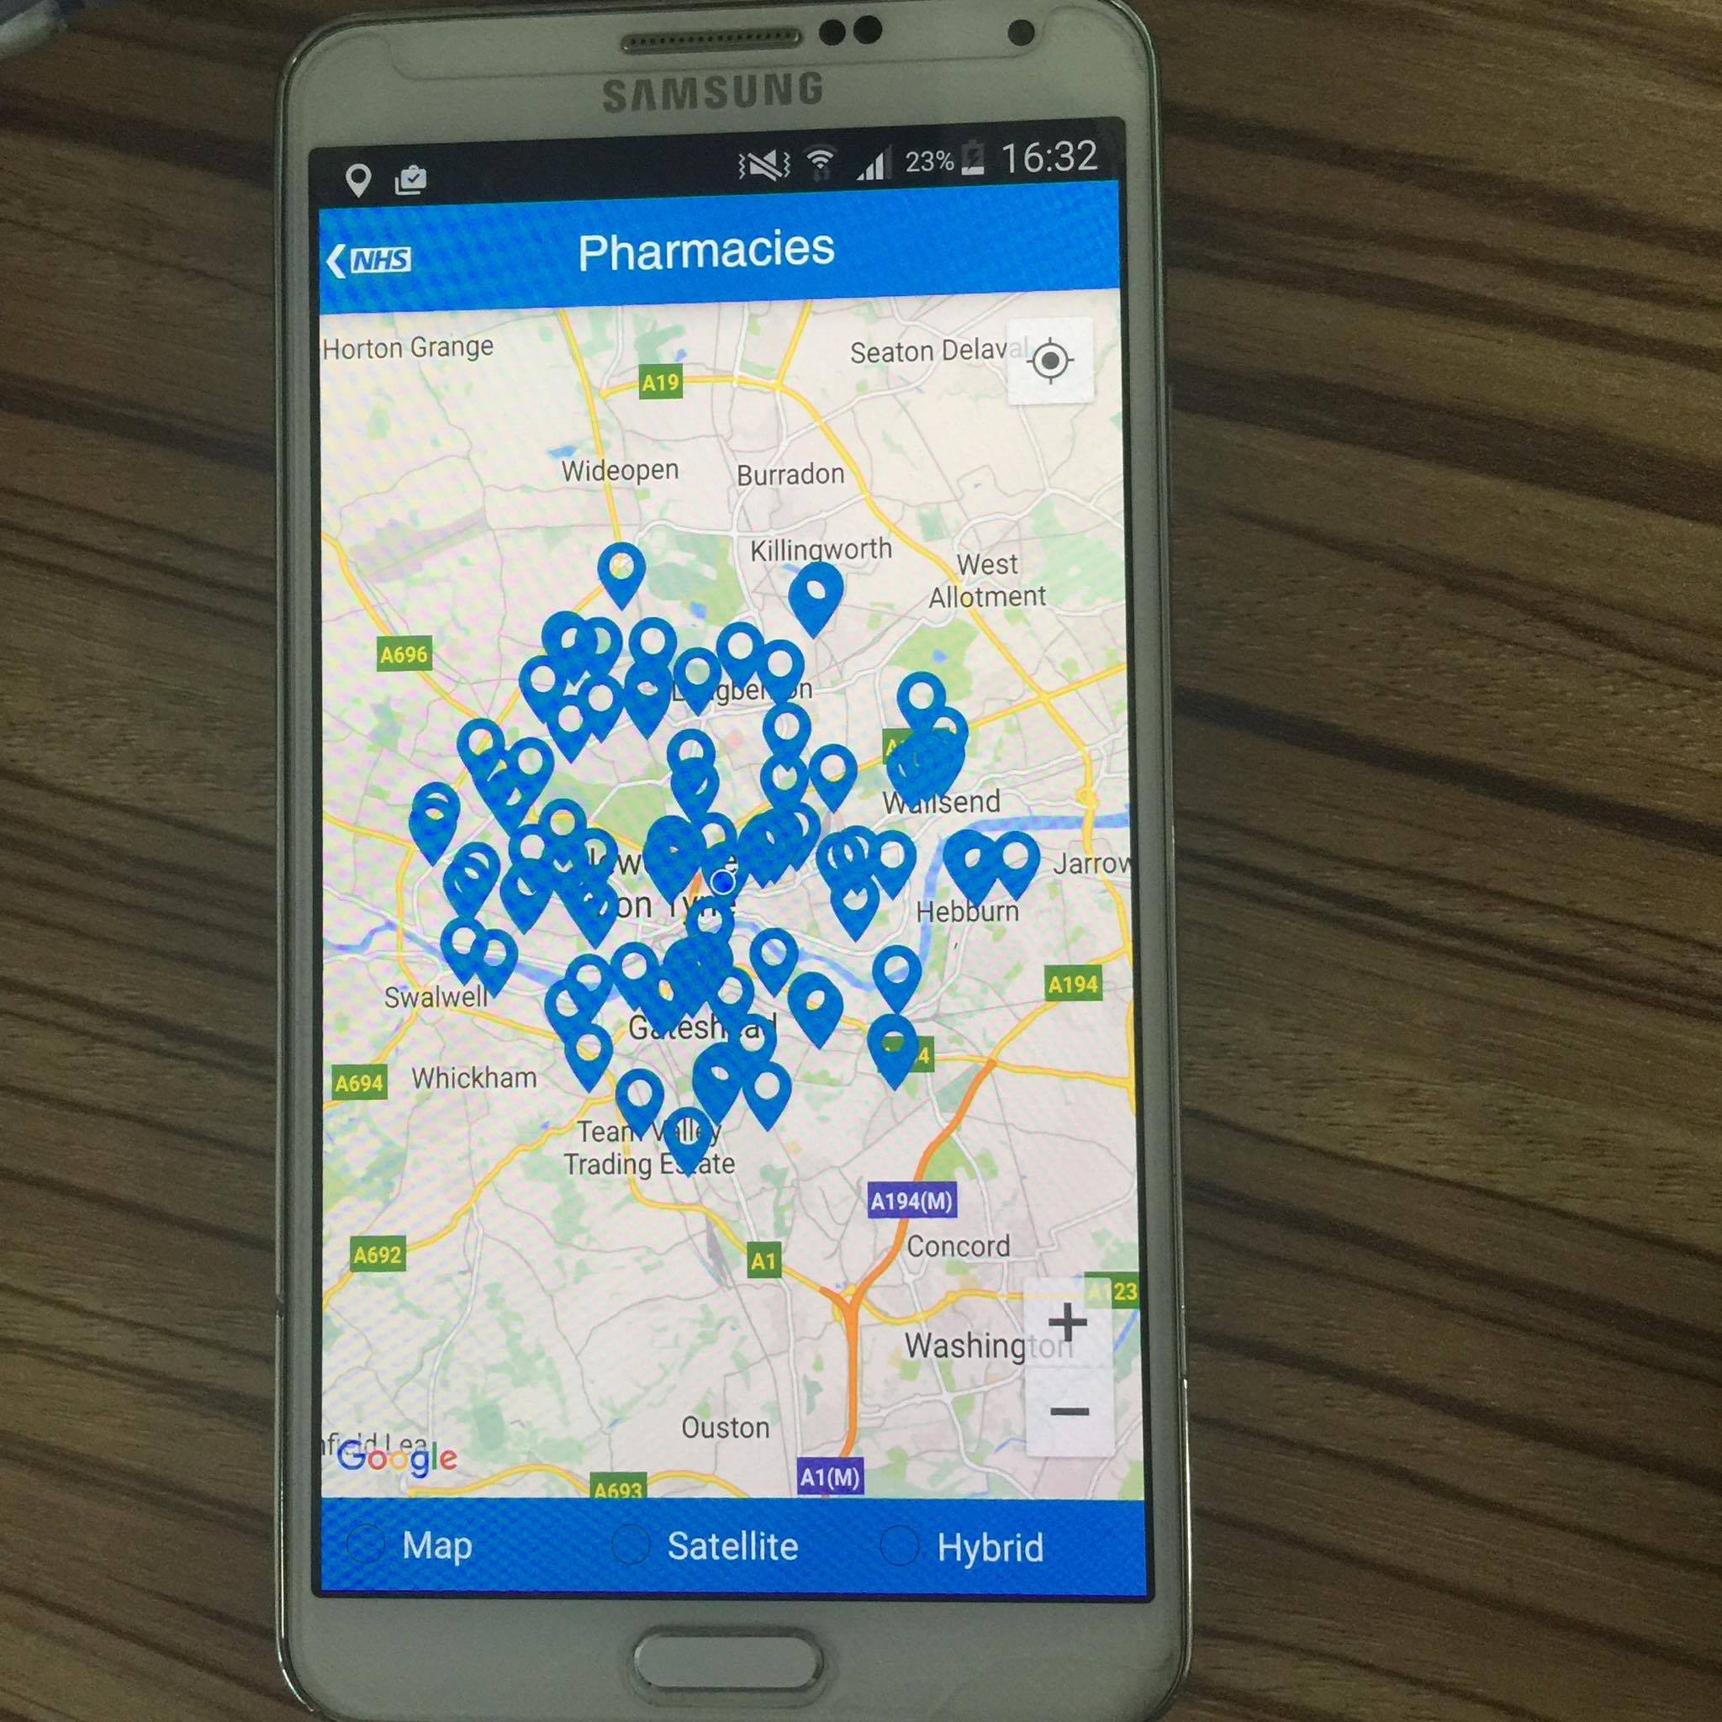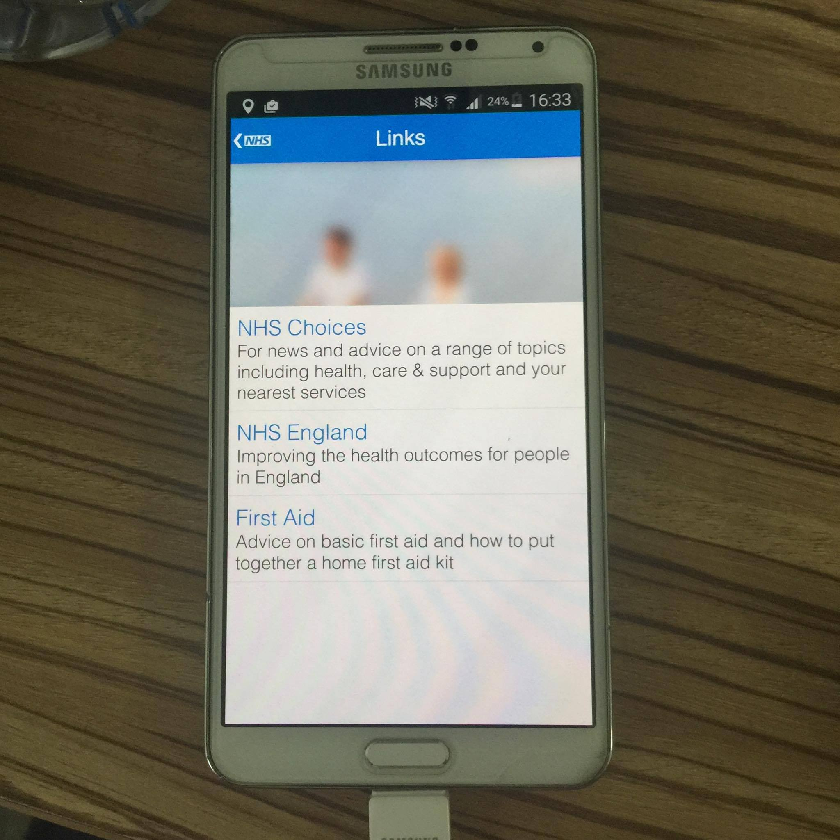

**Solution and Risks**

To sum-up this business case, I have provided a table below which shows list of all the possible solutions that will be considered to implement within this android application for the patient and risks that could be associated within some of the solutions.

|  |  |
| --- | --- |
| **Solution** | **Risks** |
| Patients will be able to find all the service within a specified radius (based on postcode). | Google Map API is constantly changing and need to ensure the functionality is robust. |
| Ability to see the appointments which are currently booked for individual users. | No risks |
| Ability to set remainders (e.g. pickup prescriptions from surgery) which then will be displayed on the appointments section. | No risks |
| Provide user with up-to-date local service news (e.g. opening time for clinics, whether or not booking available for a specified date) | Due to the time available it is impossible to implement this functionality |